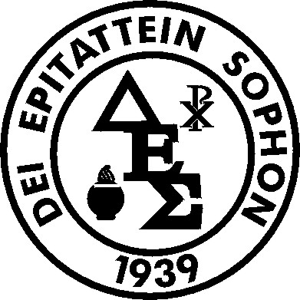 Delta Epsilon Sigma
THE SISTER BRIGID BRADY, OP, DELTA EPSILON SIGMA GRADUATE STUDENT AWARD

Named in honor of Sister Brigid Brady, OP, Ph.D., the DES Graduate Award will grant $1,500 (Fifteen hundred) to each of up to three (3) graduate student members of DES a year who have shown a strong commitment to graduate study and maintain the Society’s ideal of service to others. Sister Brigid served as a National Executive Board Member, Vice-President and past President of the Society, and was a remarkable Religious, educator, and woman. She spent sixty years as a Dominican Sister, forty-three of which she dedicated to teaching at Caldwell University. Sister Brigid challenged and aided her students to excel.
A scholar of Medieval Literature, Shakespeare Studies, and the History of the English Language, Sister Brigid was among the first professors at Caldwell to introduce classroom technology as a way to broaden student learning. A Renaissance woman, Sister Brigid also hand made her own harp and was deeply committed to the Arts. In addition to her service to DES and other societies, Sister Brigid frequently presented and published papers at the Conference on Christianity and Literature, an international society of scholars dedicated to the study of Christian themes in literature.

Requirements: Full-time student applicants will submit: (1) a three-page essay, which includes a statement of: (a) career goals, (b) academic accomplishments, (c) scholarly activity, and (d) how the applicant's goals correspond with the mission of DES; (2) a brief CV with biography (3 pp.); (3) an official transcript of graduate coursework; (4) a sample of a course paper;); and (5) a letter of recommendation which addresses the candidate’s academic work and potential. All documents must be sent electronically to the National Office (DESNational@Neumann.edu ) by March 15th, 2025
Note: Awards may be renewable . Awards will be paid directly to the University for crediting to the student account.

